Skills Workshop # 10: Journal Article Writing Sessions 1 & 2

Speaker: Dr. A. Kukreti, Director for Engineering Outreach, College of Engineering and Applied Science
Date: Friday, June 30, 2017 & Tuesday, July 12, 2017
Time: 9-10:15 AM and 9-11:30 AM, respectively
Venue: University of Cincinnati, Swift Hall, Room 516

Prepared by:
Michael Sullivan, Princeton High School
RET Participant for Project #2: “Li-S Batteries”

Dr. Anant Kukreti is Director for Engineering Outreach for the College of Engineering and Applied Science and Professor in the Department of Biomedical, Chemical and Environmental Engineering. He joined UC in August, 2000 as Head of the Department of Civil and Environmental Engineering (CEE) and before that worked for 22 years at University of Oklahoma, Norman, Oklahoma. After serving as the Department Head of CEE he was appointed as the Associate Dean for Engineering Education and Research in the College of Engineering and Applied Science in which capacity he served until August 2009. He teaches structural mechanics, with research in steel structures, seismic analysis and design, and engineering education. He has won five major university teaching awards, two Professorships, two national American Society of Engineering Education teaching awards, and is internationally recognized in his primary research field. He has extensive administrative experience in managing major NSF grants, which includes can ongoing $9 Million Math and Science Partnership grant, a $2 Million STEP grant, a $600,000 S-STEM grant, a $300,000 REU grant, and a $500,000 RET grant. He is also coordinating a $4.3 Million Choose Ohio First Scholarship grant from the Ohio Board of Regents.

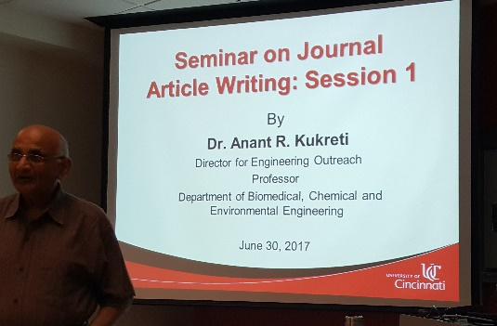
Figure 1. Dr. Kukreti introduces various ways to formally and informally communicate research results.
Dr. Kukreti (Fig. 1) opted to rely on a traditional, didactic presentation with a text-intensive PowerPoint slide deck. The purpose of the presentation was to ensure that all RET teachers were clear regarding the various options for communicating the results of their research and for promulgating RET-inspired unit plans. Supplementing the PowerPoint presentation were handouts detailing both the content of the slides and publication options.
This presentation was the first part of a two-part instructional set; to prepare for the second session (scheduled for July 12, 2017), RET teachers were instructed to determine their target path of communication and then draft up an outline for what that effort should look like, with the implication that the second session would include time for RET teachers to workshop their outlines and obtain feedback leading to successful dissemination of their research results.
Dr. Kukreti differentiated between journals and magazines, asserting that journals are academic periodicals aimed at academic professionals, whereas magazines are non-academic periodicals aimed at enthusiasts in general. Journals, according to Dr. Kukreti, could be readily ranked in accordance to the level of influence wielded by their contributors (measured through follow-on citations). For this reason, journals were seen as the pinnacle of publication options by leading researchers.
Dr. Kukreti acknowledged that some journals – particularly those that limit themselves to an online presence, with no print offerings – lack rigor with regard to quality control and peer review, and that it is incumbent upon each researcher to avoid disreputable journal outlets. He noted that the peer review process requires authors to submit responses to every reviewer comment, ensuring that the peer review process will be properly reflected in the published report.
Dr. Kukreti also encouraged RET teachers to consider whether options resulted in archival preservation of their communication efforts or were purely for the benefit of people who were able to attend a one-time event (such as a PowerPoint presentation or a local workshop). Further, it is of value to examine the frequency with which each journal is cited within the field; a natural ranking of journals based on their effective authority can be drawn in this way. In addition, it can be assumed that journals consistently ranking near the top of such a list publish papers of higher quality and value than journals that rank lower.
RET teachers who wish to communicate their progress before having enough data for conclusive assertions should consider presenting at conferences, where peer input can be obtained directly and the focus of research may be honed while still in process. Dr. Kukreti commented that presenting incomplete work at conferences is also a good way of notifying your peers of what sort of work is being done so that those who wish to coordinate may connect to do so and those who wish to avoid replicating efforts may adjust their own work appropriately. Conferences, according to Dr. Kukreti, are the primary spaces in which professional communities are built and maintained. Participation in relevant conferences is the most meaningful way to stay connected with the larger professional community.
When presenting at conferences, Dr. Kukreti advised RET teachers to ensure that the first post-title slide of the PowerPoint presentation help attendees know whether the session will be of value to them. That is, this slide should – at a glance – define the scope of the whole presentation and make clear the most likely applicability of the presentation’s content. In this way, the second slide is meant to serve as a hook for the presentation, but one that is designed to lure those specific attendees who are most likely to benefit from the presentation’s offerings.
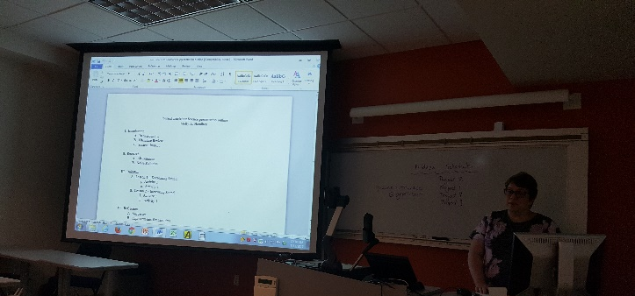
Figure 2 RET teacher Molly Hamilton shares her plans to prepare a conference paper.
This presentation was divided into two sessions. The first session, detailed above, provided RET teachers with a foundation of knowledge upon which they might make decisions about ways in which each teacher might best share the fruits of their RET experience. The second session, two weeks after the first, provided a venue for each RET teacher to share outlines or drafts of their plans to communicate about primary research, Challenge-Based Learning, and the engineering design process (Fig. 2).
During this session, Dr. Kukreti and RET Program Coordinator Debora Liberi provided feedback to each RET teacher on how best to tailor their drafts for maximum effect. In addition, RET teachers provided peer feedback, to ensure a variety of perspectives on each effort.

